Application for Participation In
The Guilford County
Voluntary Agricultural District
Or
Enhanced Voluntary Agricultural District

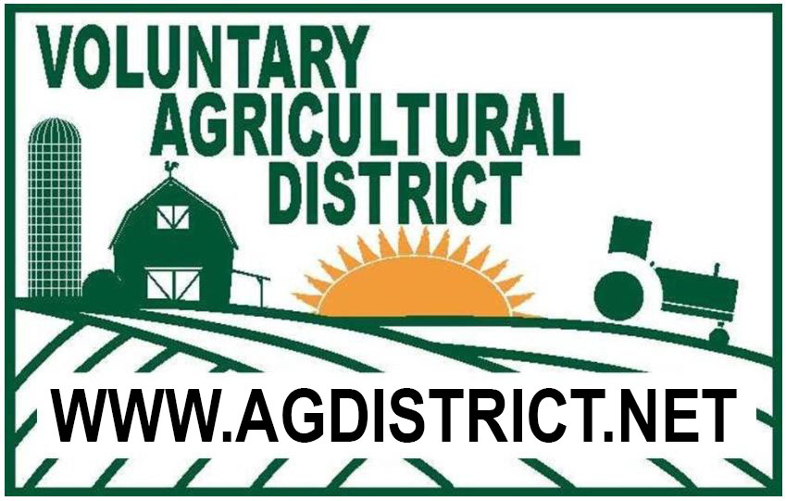

APPLICATION PROCEDURE

The application on Page 3 and 4 is to be completed and mailed to: Guilford Soil & Water Conservation District, 3309 Burlington Road, Greensboro, NC 27405. For questions call 336-641-2440

After your application is approved by the Voluntary Agricultural District Advisory Board and the County Commissioners, you will be notified when you need to sign the Conservation Agreement and the Notice of Participation.

After the documents are signed by the landowner(s), the new Agricultural District farm will be identified on a county map. The Notice of Participation will be recorded with the Guilford County Register of Deeds (EVAD only).

Voluntary Agricultural Districts
and
Enhanced Voluntary Agricultural Districts

The purpose:

…Is to promote the preservation of farmland in Guilford County, so that development and growth will be accompanied by protection of farms from non-farm development and other negative impacts on properly managed farms, recognizing the importance of agriculture to the economic and cultural life of the county.

Does my land qualify? It must be:
- 20 acres of qualified forestland or
- 10 contiguous acres of qualified farmland or
- 5 contiguous acres of qualified horticultural land
- As defined in GS 105-277.2

What are the benefits of enrollment, shared by both the Voluntary Agricultural District and the Enhanced Voluntary Agricultural District?

- No requirement to connect with Guilford County water and/or sewer systems, inside a district.
- The assessments will be held in abeyance, without interest, for qualifying farms, inside a district, until improvements on such property are connected to the water or sewer system.
- Public notification of agricultural operations to property owners, residents and other interested persons.

Are there additional benefits for enrolling in the Enhanced Voluntary Agricultural District?

- Sale of non-farm products: Landowners participating in Enhanced Districts may receive up to 25% of gross sales from the sale of non-farm products and still qualify as a bona fide farm and remain exempt from county zoning regulations
- Participating landowners are eligible to receive up to 90% cost share for installation of “Best Management Practices” under the Agriculture Cost Share Program.
- State agencies, departments and institutions that award grants to farmers are encouraged to give priority to landowners participating in Enhanced Districts.

Application for Participation in the Guilford County
Voluntary Agricultural District or
Enhanced Voluntary Agricultural District

(Chapter 15, Article III - Guilford County Code and N.C.G.S. 106-735 et seq.)

(Read and Initial)
____ I am applying for The Enhanced Voluntary Agricultural District which has a 10 year binding agreement.
____I am applying for the Voluntary Agricultural District which is a non-binding agreement

APPLICANT INFORMATION
Name (s): _______________________________________________________________

Full Address: _______________________________________________________________

________________________________State_______Zip Code____________

Phone: (day) ________________________ (evening)_____________________________

PROPERTY INFORMATION

 | PARCEL #1 | PARCEL #2 | PARCEL #3
Parcel identification number
*(ex. 01-23-4567-890-00)
USDA Tract Number**
Property Address

Township
Number of Acres
Current Land Use (Enter number of acres in production and what is being produced for each parcel)
Is this tract enrolled in Present-Use Value Program? | ___________(Y/N) | ___________(Y/N) | ___________(Y/N)
On annually planted cropland are you following a sound management plan (soil conservation plan) on highly erodible (HEL) land? | ___________(Y/N) | ___________(Y/N) | ___________(Y/N)
If not, are you willing to develop and follow a plan with Soil & Water or NRCS on these HEL fields? | ___________(Y/N) | ___________(Y/N) | ___________(Y/N)
On forestland are you following a sound management plan (forest management plan) on these fields? | ___________(Y/N) | ___________(Y/N) | ___________(Y/N)
If not, are you willing to develop and follow a plan with NC Forest Service on these fields? | ___________(Y/N) | ___________(Y/N) | ___________(Y/N)
* Found on tax bill or Guilford county GIS site (http://gcgis.co.guilford.nc.us/guilford_new/)
** Found at USDA-Farm Service Agency or Soil & Water Conservation District Office
(Please continue to back of this form)
ADDITIONAL TRACTS:

 | PARCEL #4 | PARCEL #5 | PARCEL #6
Parcel identification number
*(ex. 01-23-4567-890-00)
USDA Tract Number**
Property Address

Township
Number of Acres
Current Land Use (Enter number of acres in production and what is being produced for each parcel)
Is this tract enrolled in Present-Use Value Program? | ___________(Y/N) | ___________(Y/N) | ___________(Y/N)
On annually planted cropland are you following a sound management plan (soil conservation plan) on highly erodible (HEL) land? | ___________(Y/N) | ___________(Y/N) | ___________(Y/N)
If not, are you willing to develop and follow a plan with Soil & Water or NRCS on these HEL fields? | ___________(Y/N) | ___________(Y/N) | ___________(Y/N)
On forestland are you following a sound management plan (forest management plan) on these fields? | ___________(Y/N) | ___________(Y/N) | ___________(Y/N)
If not, are you willing to develop and follow a plan with NC Forest Service on these fields? | ___________(Y/N) | ___________(Y/N) | ___________(Y/N)
* Found on tax bill or Guilford county GIS site (http://gcgis.co.guilford.nc.us/guilford_new/)
** Found at USDA-Farm Service Agency or Soil & Water Conservation District Office

The Conservation Agreement for the Agricultural Districts is for 10 years. The Agreement shall be deemed automatically renewed for an additional term of 3 years, unless either the Advisory Board or the landowner gives written notice to the contrary prior to the termination date of the Conservation Agreement. At the end of each 3 year term the Conservation Agreement shall automatically renew for an additional 3 year term unless notice of termination is given.

I hereby submit my application for inclusion in the Guilford County’s: (Please check one)
________________________ENHANCED Voluntary Agricultural District OR
________________________Voluntary Agricultural District

Signature of Owners/Applicants: _________________________________ Date: _____________

_________________________________ Date: _____________
_________________________________ Date: _____________

_________________________________ Date: _____________

Mail to: Guilford Soil & Water Conservation District
Attention: Voluntary Agricultural Districts
3309 Burlington Road, Greensboro, NC 27405-7605
(Revised 7/22/21)

